**PRACTICAL 5**

**Create an AKS cluster**

**a. From the portal**

**Step 1**: Sign in to the Azure portal at [https://portal.azure.com](https://portal.azure.com/).

**Step 2**: On the Azure portal menu or from the **Home** page, select **Create a resource**.

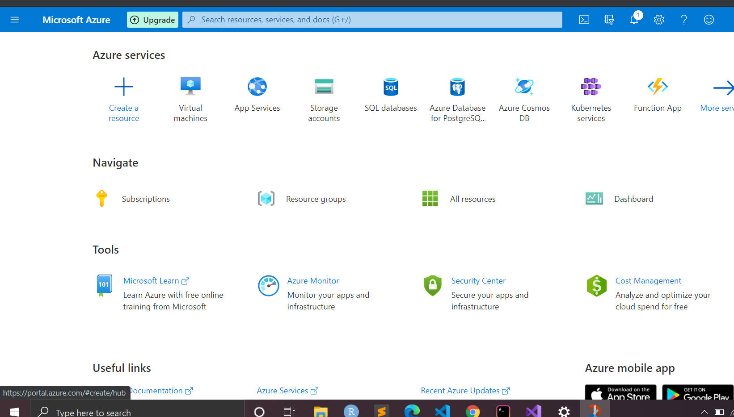

**Step 3**: Select **Containers** > **Kubernetes Service**.

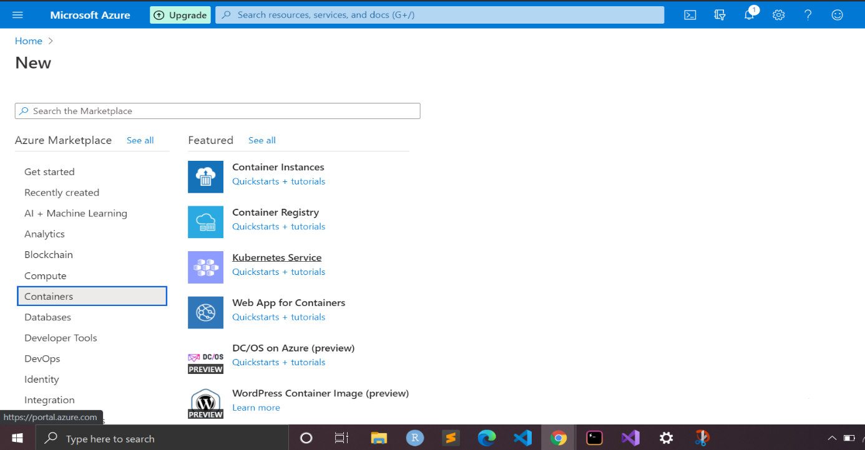

**Step 4**: On the **Basics** page, configure the following options:

* **Project details**: Select an Azure **Subscription**, then select or create an Azure **Resource group**, such as *myResourceGroup*.
* **Cluster details**: Enter a **Kubernetes cluster name**, such as *myCluster*. Select a **Region** and **Kubernetes version** for the AKS cluster.
* **Primary node pool**: Select a VM **Node size** for the AKS nodes. The VM size *can't* be changed once an AKS cluster has been deployed. - Select the number of nodes to deploy into the cluster. Set **Node count** to *1*. Node count *can* be adjusted after the cluster has been deployed.

Select Next: Node pools when complete.

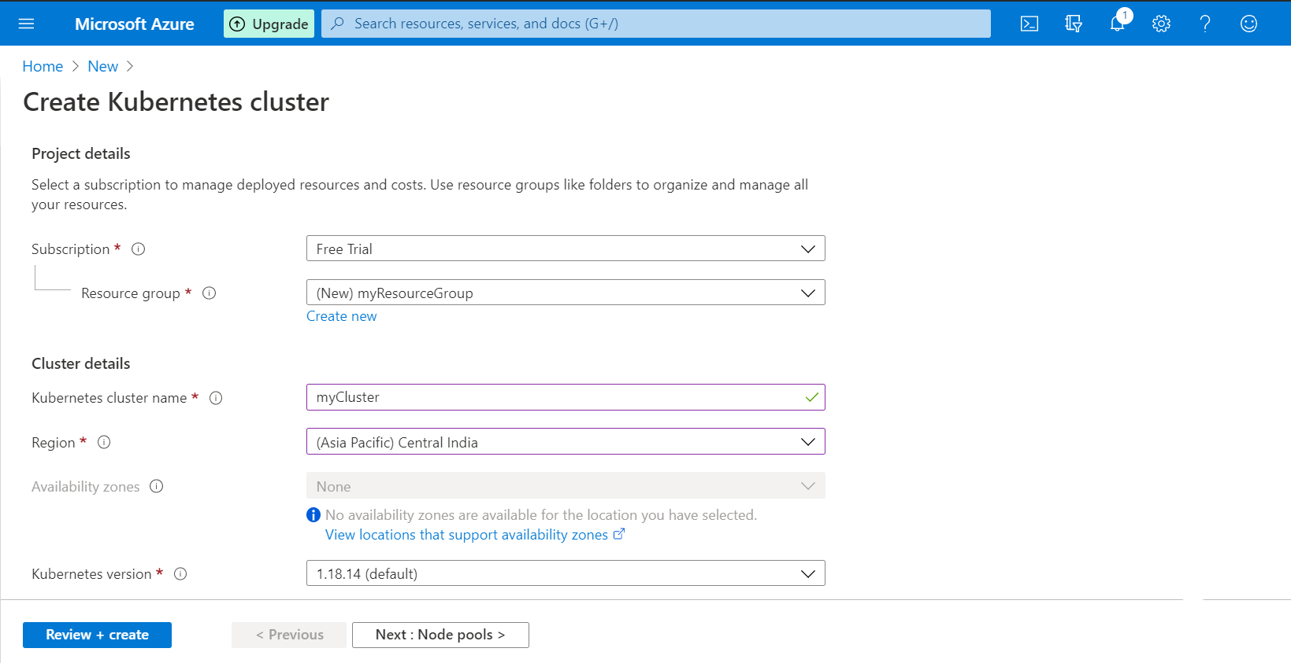

**Step 5**: On the **Node pools** page, keep the default options. At the bottom of the screen, click **Next: Authentication.** 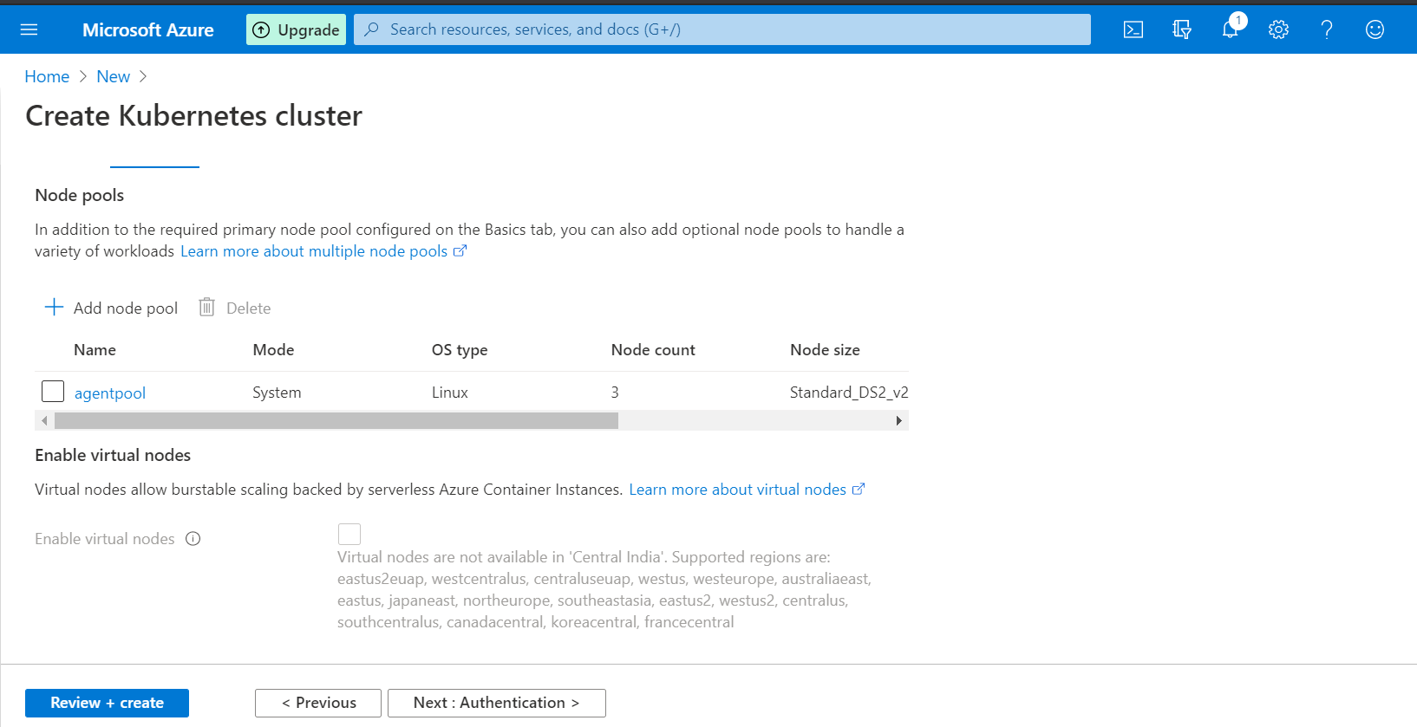

**Step 6**: On the **Authentication** page, configure the following options:

* Create a new service principal by leaving the **Service Principal** field with **(new) default service principal**. Or you can choose *Configure service principal* to use an existing one. If you use an existing one, you will need to provide the SPN client ID and secret.
* Enable the option for Kubernetes role-based access control (Kubernetes RBAC). This will provide more fine-grained control over access to the Kubernetes resources deployed in your AKS cluster

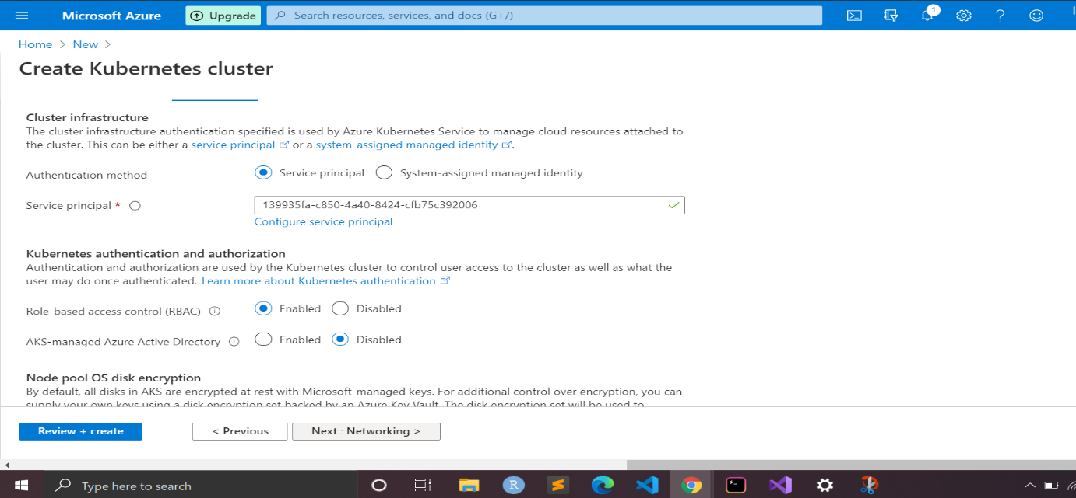

**Step 7**: By default, *Basic* networking, Integrations and tags is used, and Azure Monitor for containers is enabled. 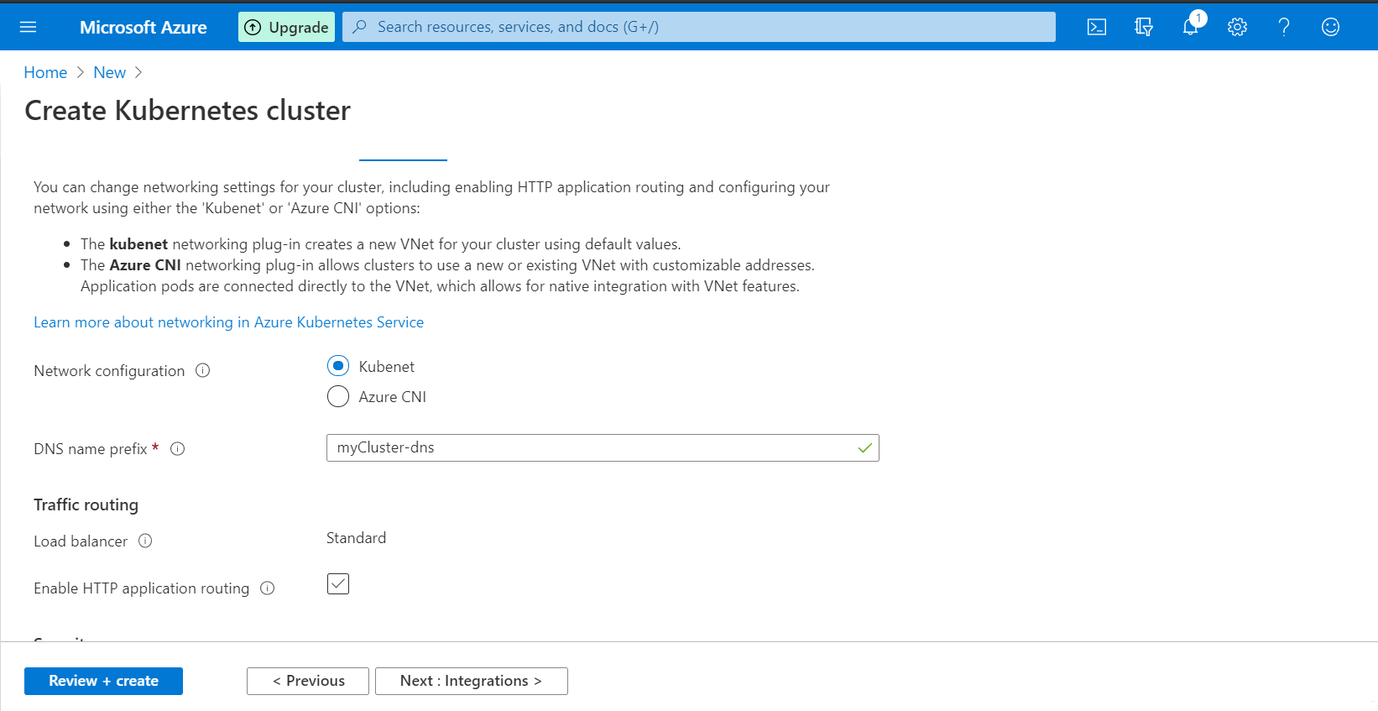

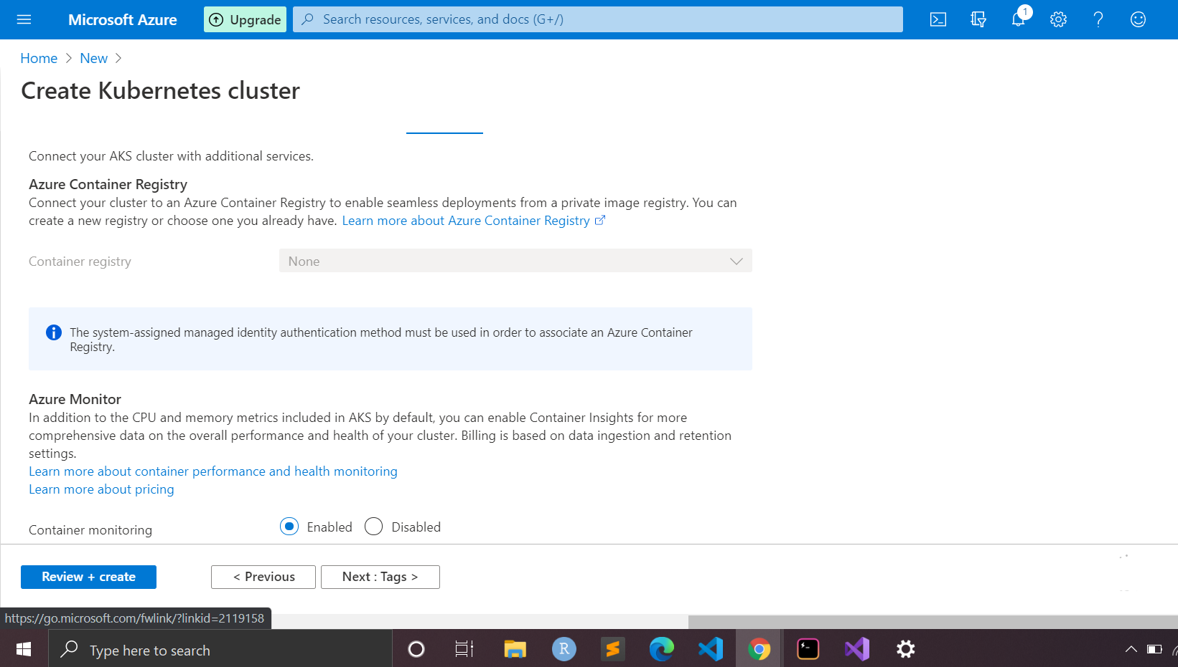

 Click Review + create and then Create when validation completes.

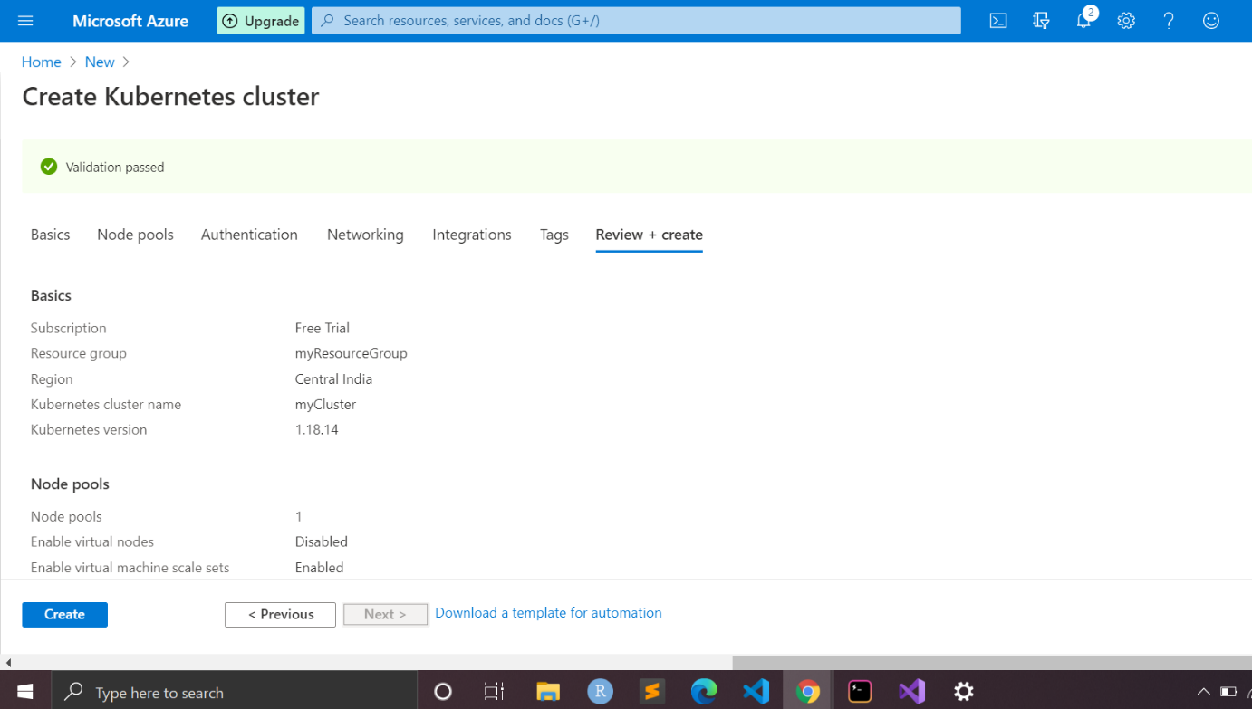

**Step 8**: It takes a few minutes to create the AKS cluster. When your deployment is complete, click Go to resource, or browse to the AKS cluster resource group, such as *myResourceGroup*, and select the AKS resource, such as *myCluster*. The AKS cluster dashboard is shown below:

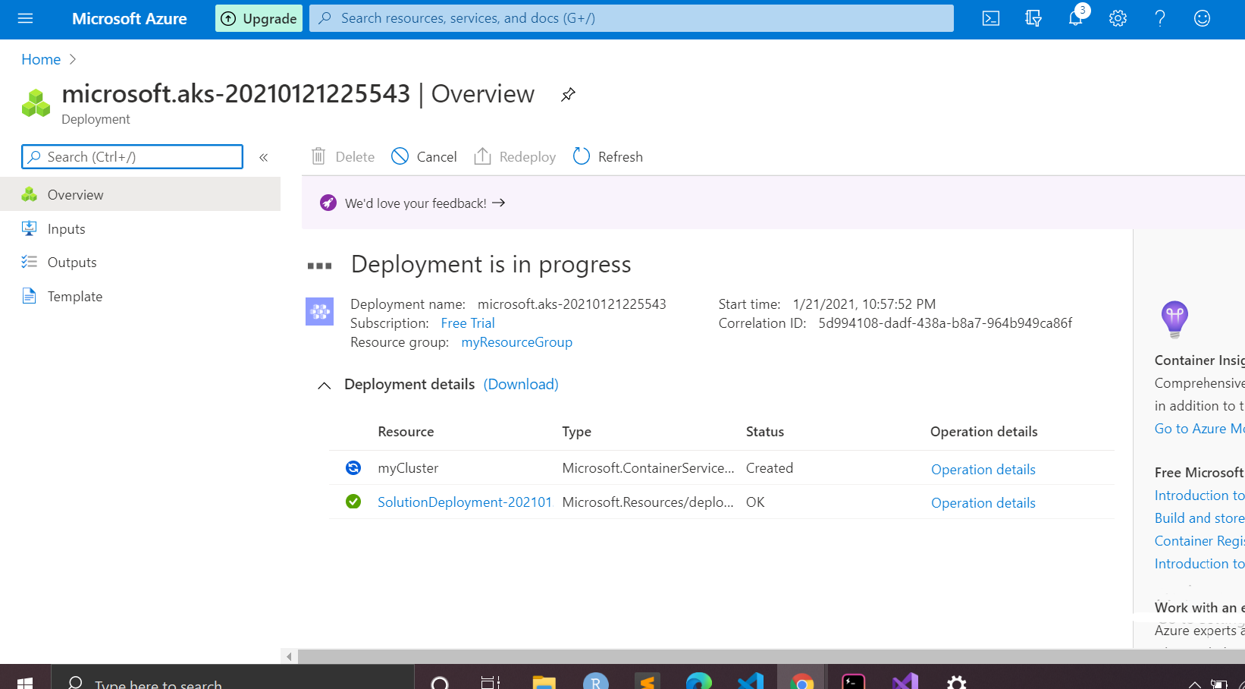

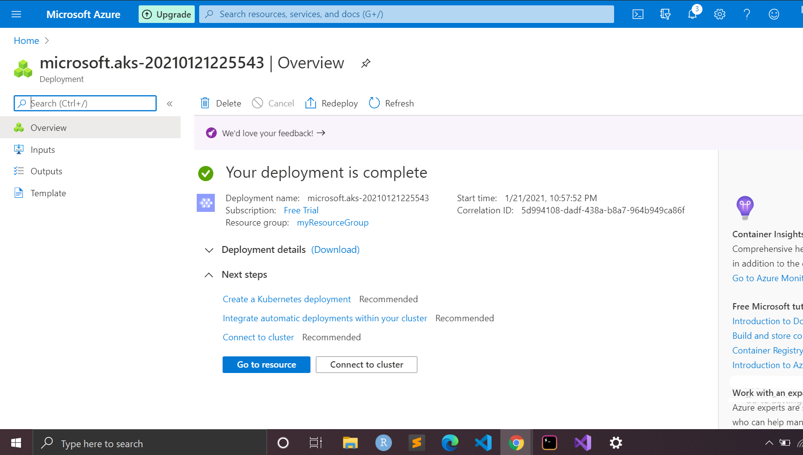

1. **From azure CLI**

**Step 1:**  [Install](https://docs.microsoft.com/en-us/cli/azure/install-azure-cli) the Azure CLI to run CLI reference commands.

**Step 2:** Sign in to the Azure CLI by using the [az login](https://docs.microsoft.com/en-us/cli/azure/reference-index#az_login) command. To finish the authentication process, follow the steps displayed in your terminal.

**Step 3**: Run [az version](https://docs.microsoft.com/en-us/cli/azure/reference-index?#az_version) to find the version and dependent libraries that are installed. To upgrade to the latest version, run [az upgrade](https://docs.microsoft.com/en-us/cli/azure/reference-index?#az_upgrade).

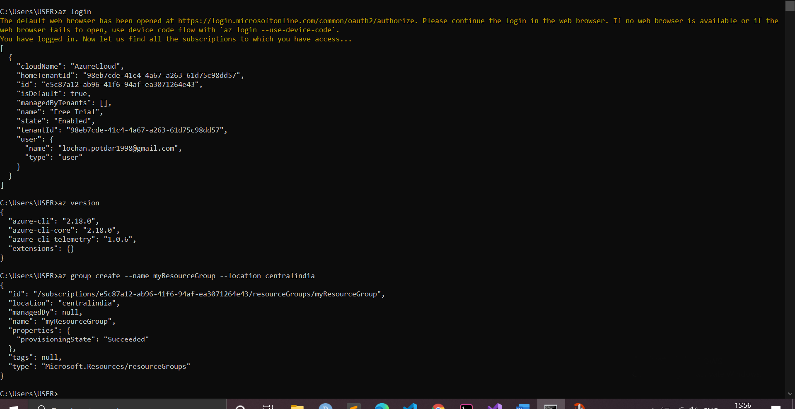

**Step 4**: An Azure resource group is a logical group in which Azure resources are deployed and managed. When you create a resource group, you are asked to specify a location. This location is where resource group metadata is stored, it is also where your resources run in Azure if you don't specify another region during resource creation. Create a resource group using the [az group create](https://docs.microsoft.com/en-us/cli/azure/group#az-group-create) command.

**Step 5**: The following example creates a resource group named myResourceGroup in the centralindia location.

az group create --name myResourceGroup --location centralindia

Output similar to the following example indicates the resource group has been created successfully:

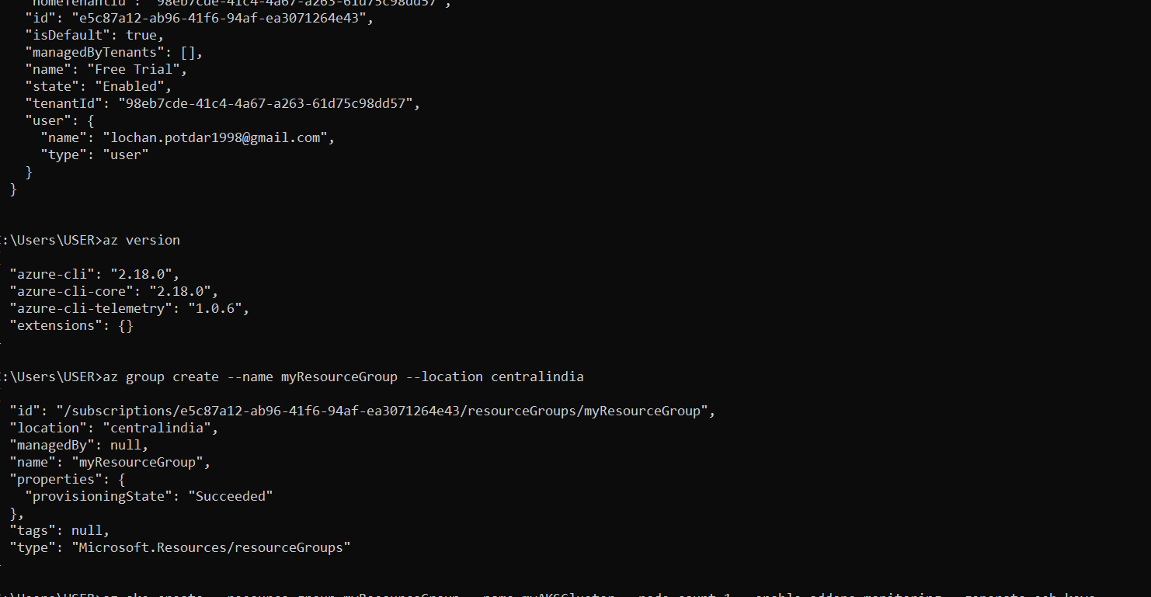

**Step 6**: Use the [az aks create](https://docs.microsoft.com/en-us/cli/azure/aks?view=azure-cli-latest&preserve-view=true#az-aks-create) command to create an AKS cluster. The following example creates a cluster named *myAKSCluster* with one node. This will take several minutes to complete.

az aks create --resource-group myResourceGroup --name myAKSCluster --node-count 1 --enable-addons monitoring --generate-ssh-keys 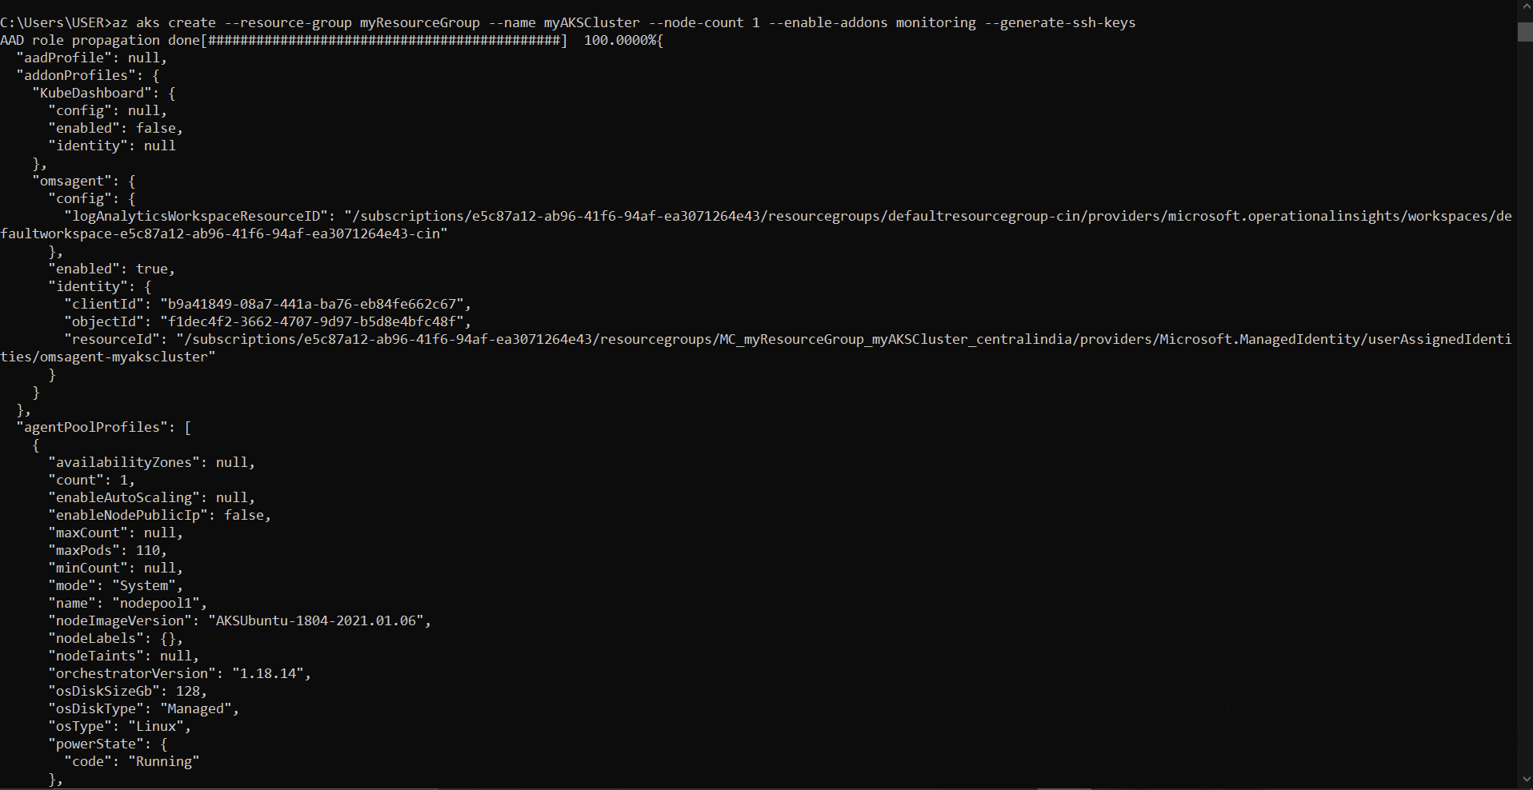

After a few minutes, the command completes and returns JSON-formatted information about the cluster.

# **Practical no 6**

**Create an Application Gateway Using Ocelot and Securing APIs with Azure AD**

**Q6: Create an Application Gateway Using Ocelot and Securing APIs with Azure AD.**

API Gateway is an API management tool that usually sits between the external caller (Web or Mobile) and the internal services.

The API Gateway can provide multiple features like:

1. Routing Request
2. Aggregations
3. Authentication
4. Authorization
5. Rate Limiting
6. Caching
7. Load Balancing ETC.

Ocelot is an ASP.Net Core (Supports .Net Core 3.1) API Gateway. It's a NuGet package, which can be added to any ASP.Net Core application to make it an API Gateway. Ocelot API Gateway supports all the features that any standard API Gateway does.

**Steps:**

1. Create an ASP.NET Core Web Application Project.

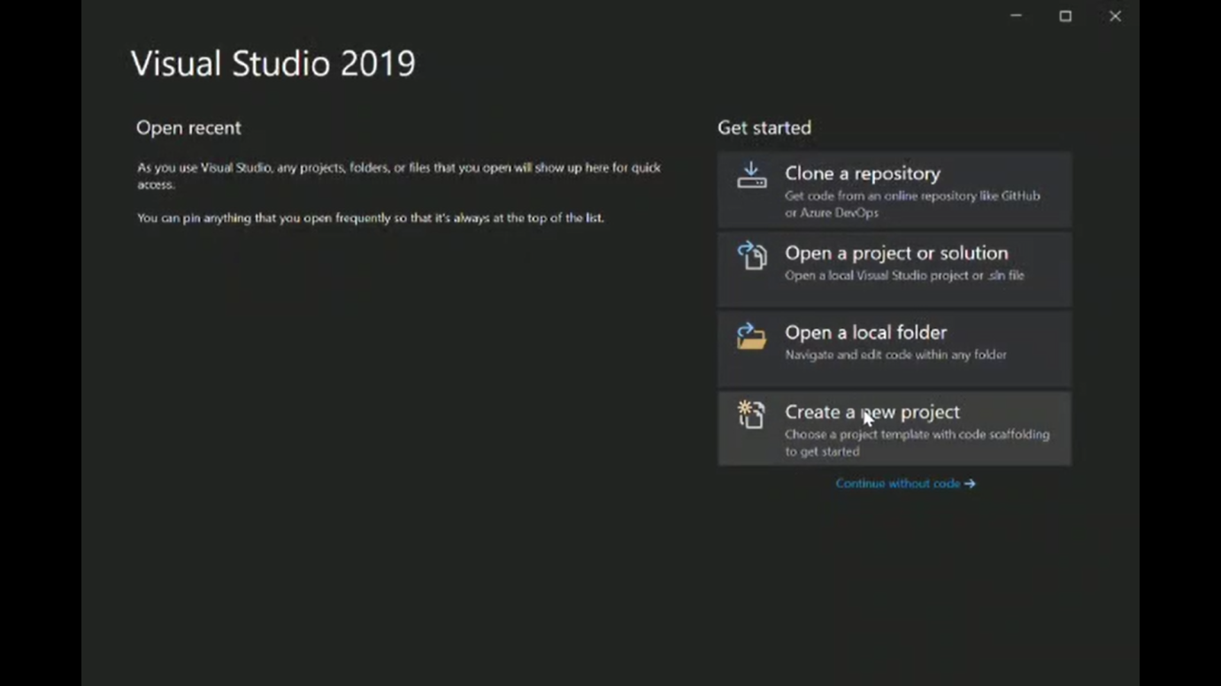

1. Create an empty ASP.NET Core 3.1 and and give a name of the Project.

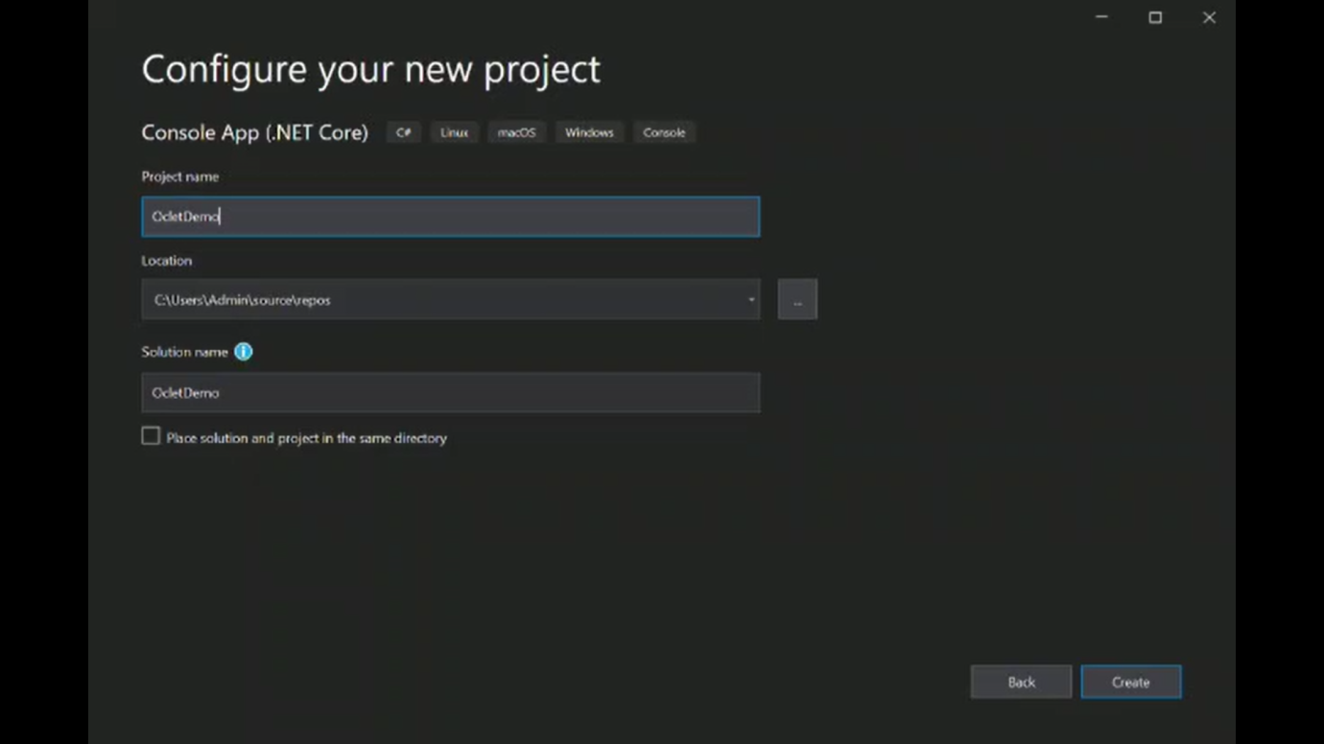

1. Go to Program.cs file and add logging code.

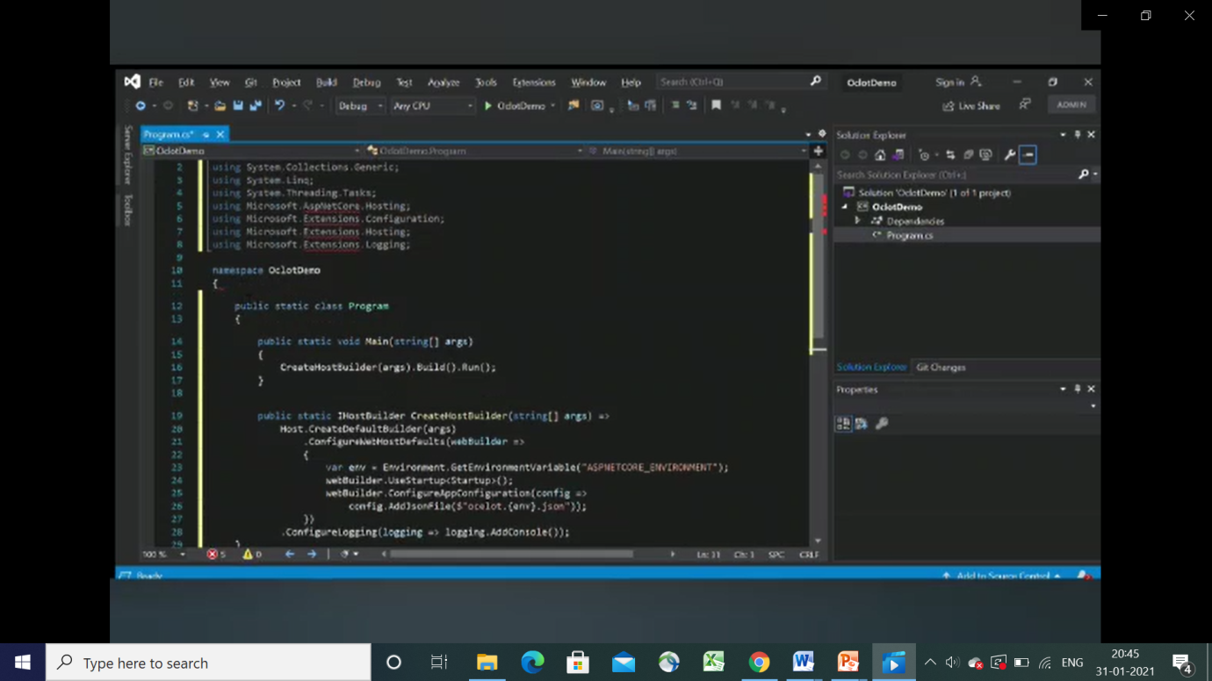

1. Now add new NuGet package for Ocelot

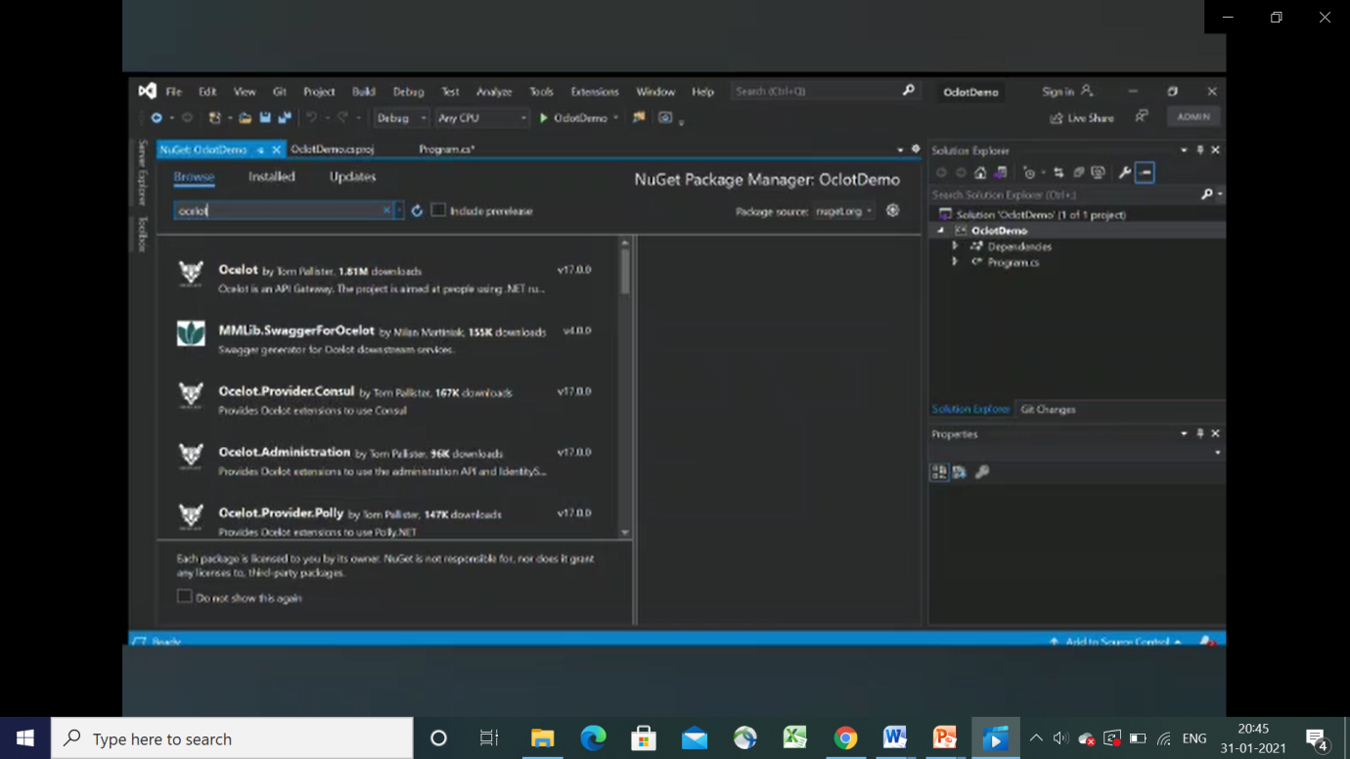

1. Click on Project -> Manage NuGet Package -> Click on Browse -> Search for ocelot package -> install.

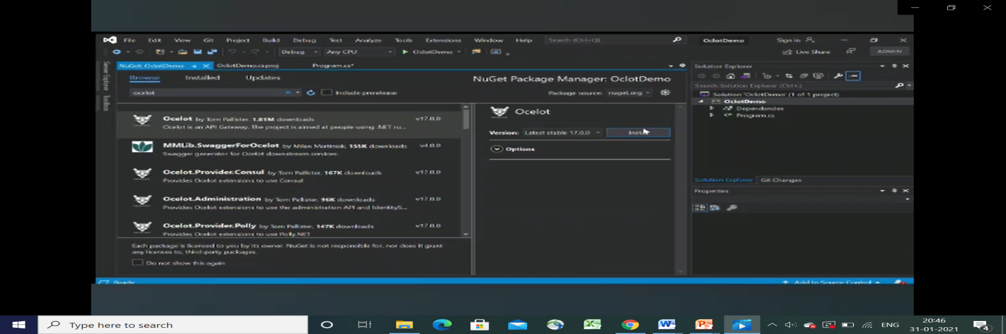

1. Once Ocelot Package is installed Go to Startup.cs

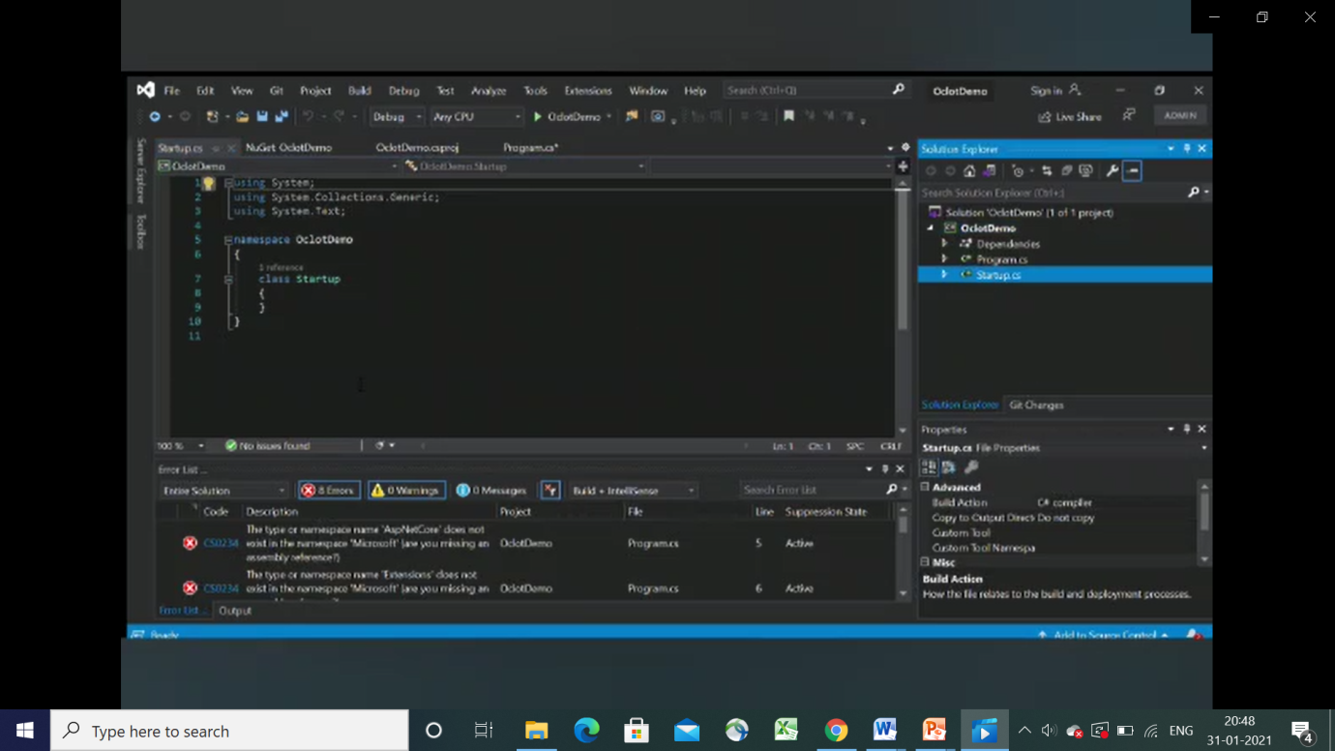

1. Now to Configure Ocelot add services.Addocelot() and app.UseOcelot().Wait() code.

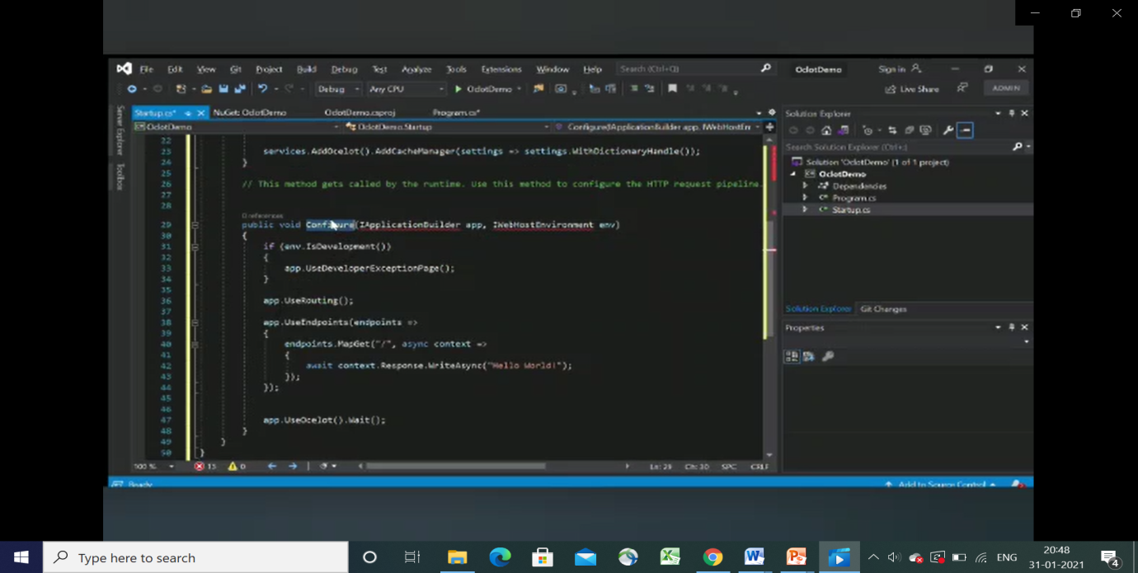

1. Now add the Ocelot JSON file.

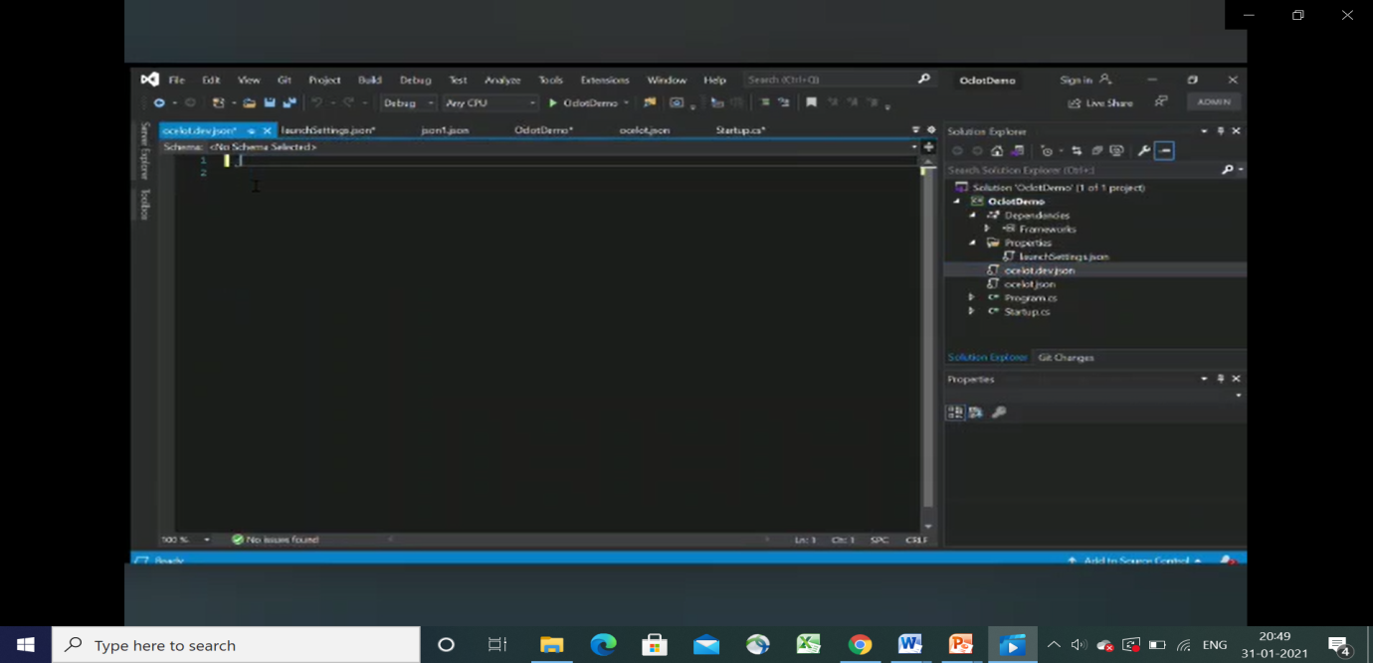

1. Click on Project name -> Add -> New Item -> JSON File ->(Give name)
2. Add JSON Code.

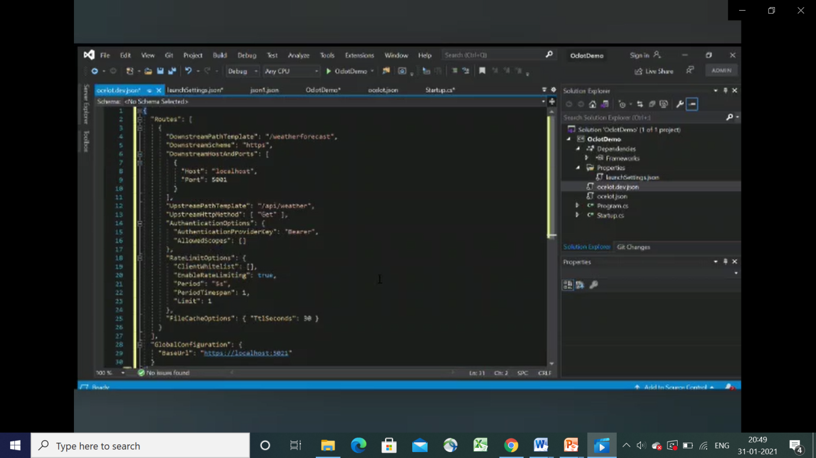

1. Create an Environmental Variable

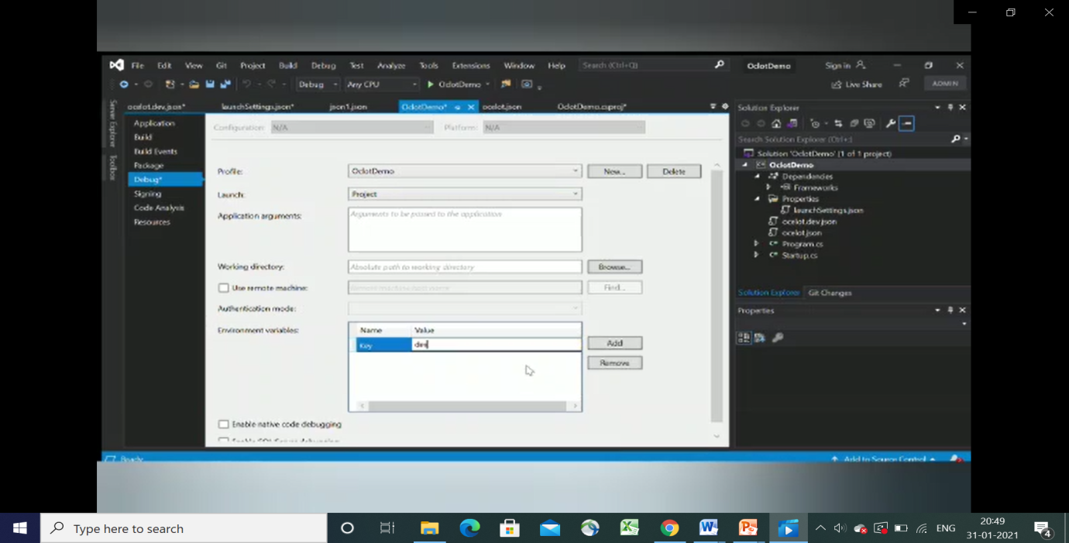

1. Change localhost to 5020 and 5021.

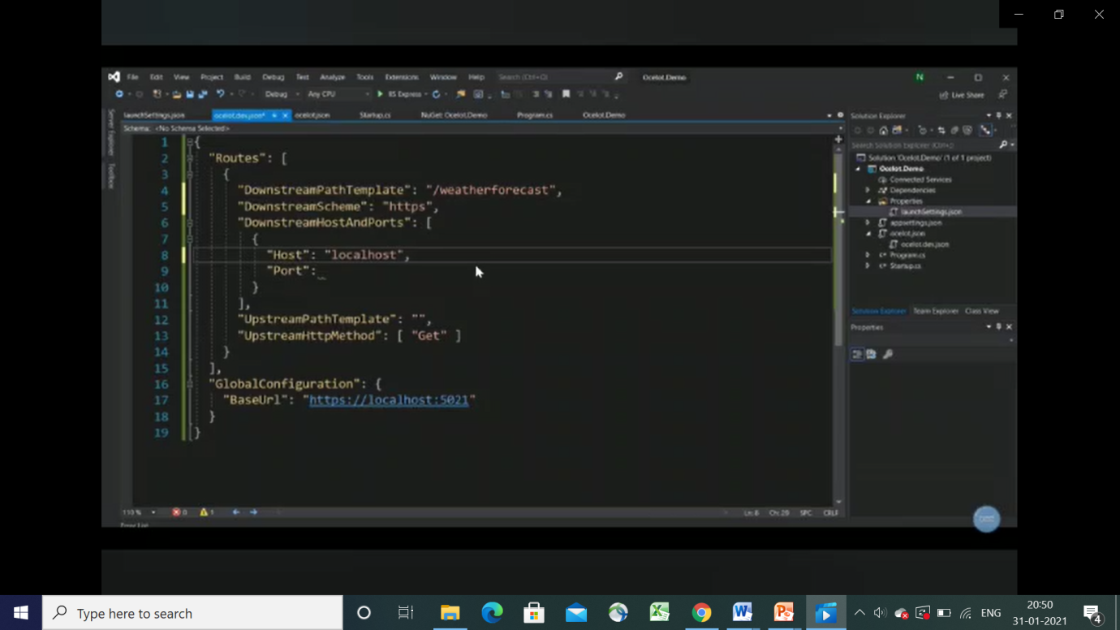

1. Add Configuration to the system.

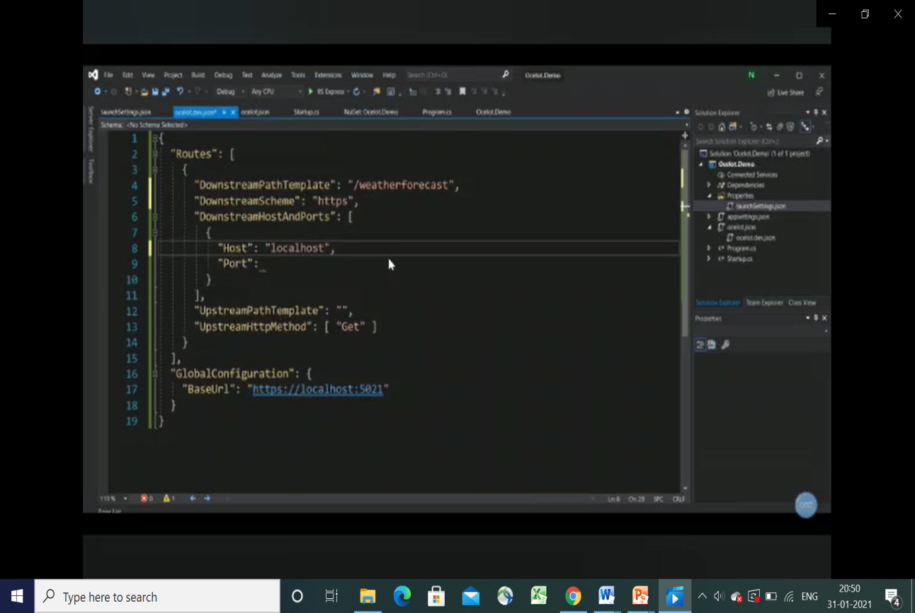

1. Run the project.

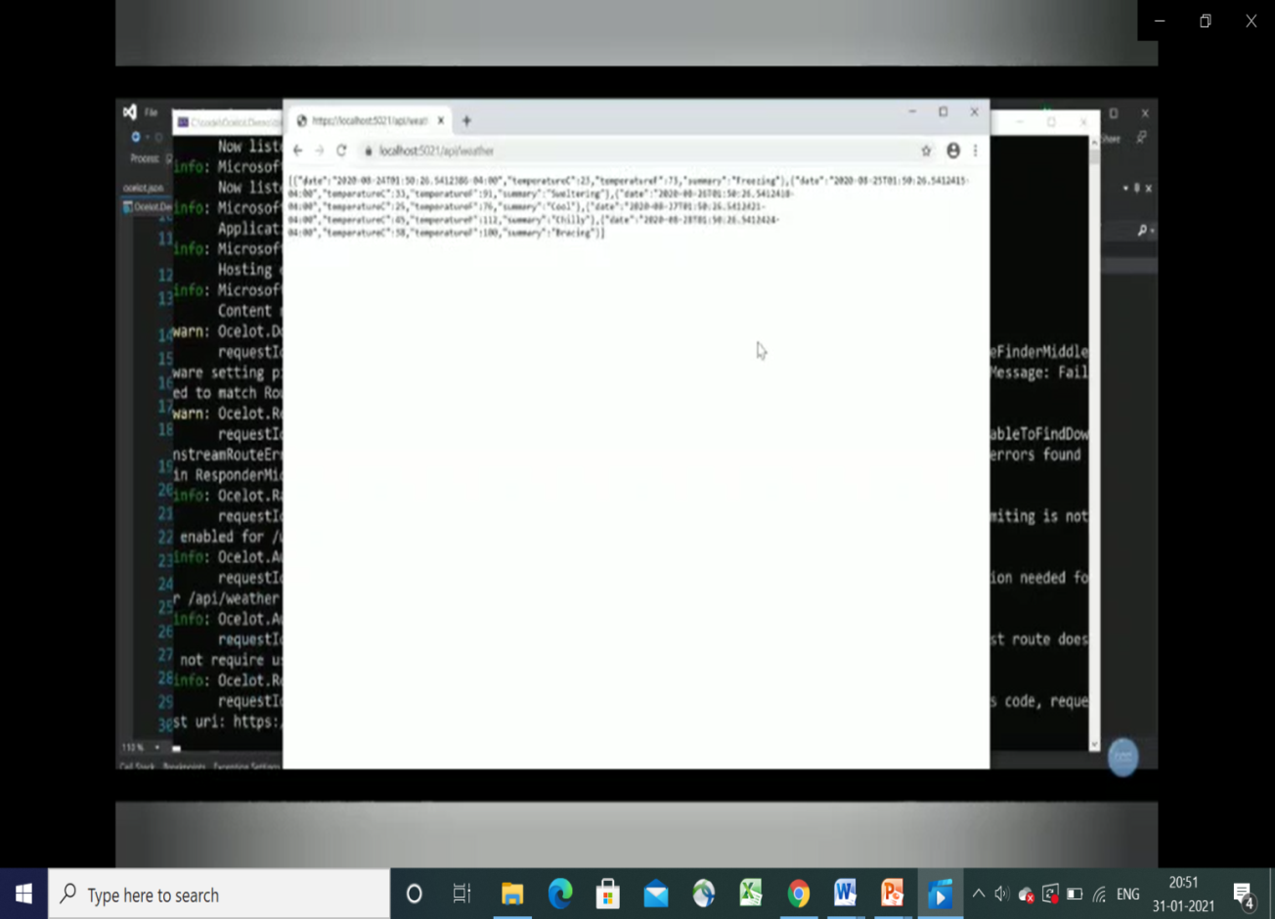

**Code:**

**Program.cs file**

using System;

using System.Collections.Generic;

using System.Linq;

using System.Threading.Tasks;

using Microsoft.AspNetCore.Hosting;

using Microsoft.Extensions.Configuration;

using Microsoft.Extensions.Hosting;

using Microsoft.Extensions.Logging;

namespace Oclot.Demo

{

public static class Program

{

public static void Main(string[] args)

{

CreateHostBuilder(args).Build().Run(); }

public static IHostBuilder CreateHostBuilder(string[] args) =>

Host.CreateDefaultBuilder(args)

.ConfigureWebHostDefaults(webBuilder =>

{

var env = Environment.GetEnvironmentVariable("ASPNETCORE_ENVIRONMENT");

webBuilder.UseStartup<Startup>();

webBuilder.ConfigureAppConfiguration(config => config.AddJsonFile($"ocelot.{env}.json"));

})

.ConfigureLogging(logging => logging.AddConsole());

}

}

**Startup.cs file**

namespace Oclot.Demo

{

public class Startup

{

public void ConfigureServices(IServiceCollection services)

{

services.AddOcelot().AddCacheManager(settings => settings.WithDictionaryHandle());

}

public void Configure(IApplicationBuilder app, IWebHostEnvironment env)

{

if (env.IsDevelopment())

{

app.UseDeveloperExceptionPage();

}

app.UseRouting();

app.UseEndpoints(endpoints =>

{

endpoints.MapGet("/", async context =>

{

await context.Response.WriteAsync("Hello World!");

});

});

app.UseOcelot().Wait();

}

}

}

**JSON file**

{

"Routes": [

{

"DownstreamPathTemplate": "/weatherforecast",

"DownstreamScheme": "https",

"DownstreamHostAndPorts": [

{

"Host": "localhost",

"Port": 5001

} ],

"UpstreamPathTemplate": "/api/weather",

"UpstreamHttpMethod": [ "Get" ],

"AuthenticationOptions": {

"AuthenticationProviderKey": "Bearer",

"AllowedScopes": [] },

"RateLimitOptions": {

"ClientWhitelist": [],

"EnableRateLimiting": true,

"Period": "5s",

"PeriodTimespan": 1,

"Limit": 1 },

"FileCacheOptions": { "TtlSeconds": 30 }

}],

"GlobalConfiguration": {

"BaseUrl": "https://localhost:5021"

}

}

**OUTPUT**

